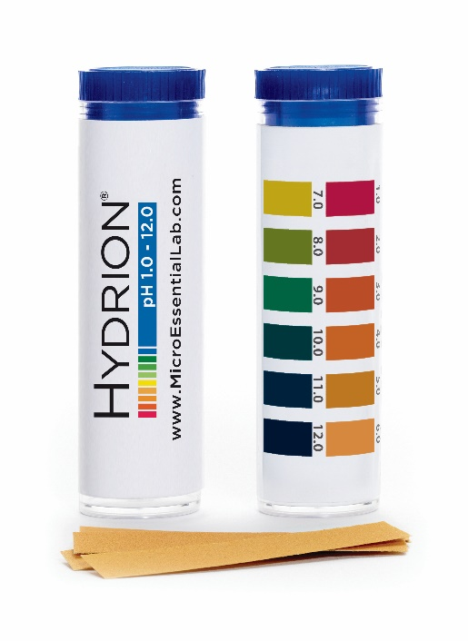
Hydrion pH test strips 1-12

Overview
Each carton contains 10 vials. Each vial contains 100 strips.
Description: Hydrion pH Paper, the ultimate in wide range, general purpose pH papers has a distinct color match at full pH units:[1.0][2.0][3.0][4.0][5.0][6.0][7.0][8.0][9.0][10.0][11.0][12.0].
Hydrion pH Paper provides: A direct reading pH paper with the widest range available in a single paper. A simple, single color match for all pH values distinct and easily matched color separations, accurate, reproducible readings with an immediate response.
Hydrion 1-12 pH Paper is a general use pH paper that can be used for: Classroom Demonstrations, Hospital Laboratories, General Laboratories, Industrial Testing, Food Service Safety, and Emergency Testing.

PRODUCT DIRECTIONS
Simply dip a pH strip into the test solution, then instantly compare the resulting color with the matching pH color chart.
Disclaimer: All information on this web site is for informational purposes only. Under no circumstance is any product on this site intended to diagnose, treat, cure or prevent any disease or condition. Please contact a medical doctor to diagnose and treat any medical condition.

