Hydrion (QC-1001) Quat Dispenser 0-1000PPM
(QC-1001B S20-QUATT-QUATCK-SRB)
Quaternary Ammonium Compound Test Paper
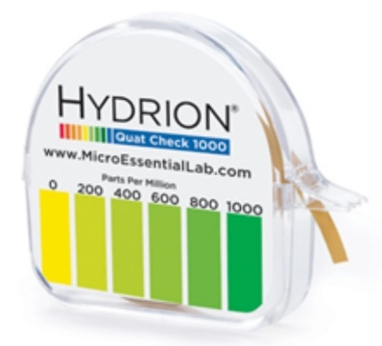

Overview
Hydrion QC-1001 Quaternary Test Paper provides a simple, reliable, and economical means to measure the concentration of Quaternary Sanitizers, including n-alkyldimethylbenzyl and/or nalkyl dimethyl ethyl benzyl ammonium chloride, and Rocall II. With color matches at 0-100-400-600-800-1000 ppm (parts per million), the test paper measures concentrations between 0-1000 ppm, detecting exhaustion of solutions that should be replaced as well as helping to avoid using excessive amounts of sanitizing agents.
Federal, State and Local health regulations require users of Quaternary Ammonium Sanitizer Solutions to have appropriate test kits available to verify the strength of sanitizer solutions. Sanitizer solutions are essential in the food service industry to ensure that sanitizers are at the proper concentration specified by the individual manufacturer.
Each carton contains 10 kits, each consisting of a 15-foot roll of test paper and matching color chart.

PRODUCT DIRECTIONS
Dip the strip into the sanitizing solution for 10 seconds, then instantly compare the resulting color with the enclosed color chart which matches concentrations of 0-100-400-600-800-1000 ppm. Test solution should be between 65 and 75 degrees Fahrenheit.
Contact your Local, State or Federal Health Department for Quaternary Ammonium Sanitizer concentration requirements. These concentrations may vary depending on your specific application.

